EXPT NO:1 | Implementation of data charts
DATE: 06.01.2026 | Implementation of data charts

PRE-LAB QUESTIONS (PROVIDE BRIEF ANSWERS TO THE FOLLOWING QUESTIONS)

- How can visualization help an academic institution improve student outcomes? Ans: Visualization helps identify weak subjects and performance trends, enabling timely academic support and improved teaching strategies.
- Which chart types are suitable for comparing subject-wise performance?
Ans: Bar charts and column charts are suitable for comparing subject-wise performance.

- What type of data scale is used for student marks?
Ans: Student marks use a ratio scale because they have a true zero and equal intervals.

- Why should raw academic data be cleaned before visualization?
Ans: Data cleaning removes errors and missing values, ensuring accurate and meaningful visual analysis.

- How does visualization support evidence-based decision making?
Ans: Visualization presents data clearly, helping administrators make decisions based on actual performance patterns.
IN-LAB EXERCISE:
OBJECTIVE:
To design appropriate data charts to analyze and compare academic performance indicators.
SCENARIO:
An autonomous engineering college wants to analyze internal assessment performance of first- year students across five subjects to identify difficult courses and improve teaching strategies.
IN-LAB TASKS (Using R Language)
- Load required R libraries (ggplot2, dplyr)
- Import dataset using read.csv()
- Perform basic data preprocessing
- Create bar chart for subject-wise average marks
- Generate line chart for performance trend across tests
- Plot pie chart for grade distribution

SCREENSHOT OF CODE
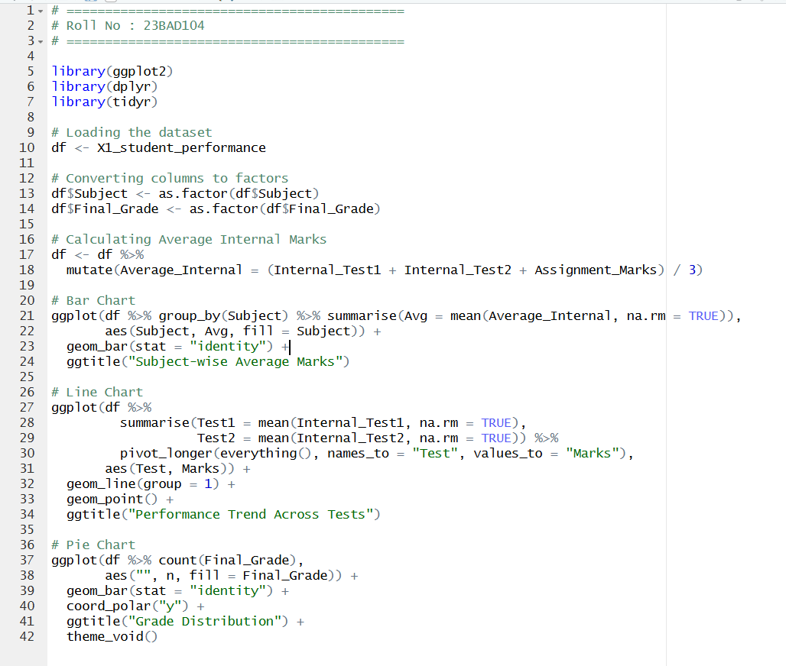
SCREENSHOT OF OUTPUT
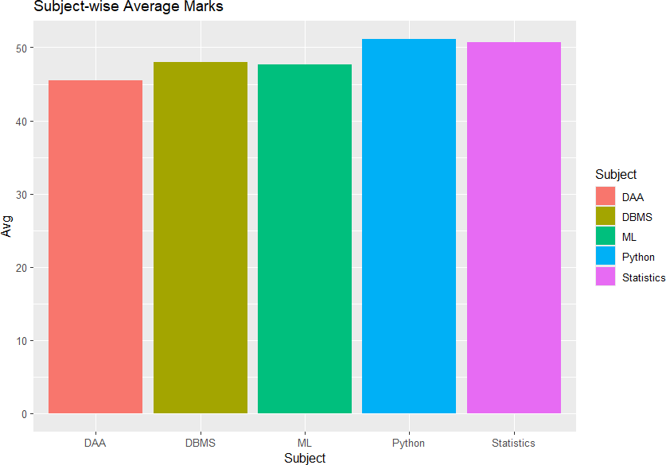

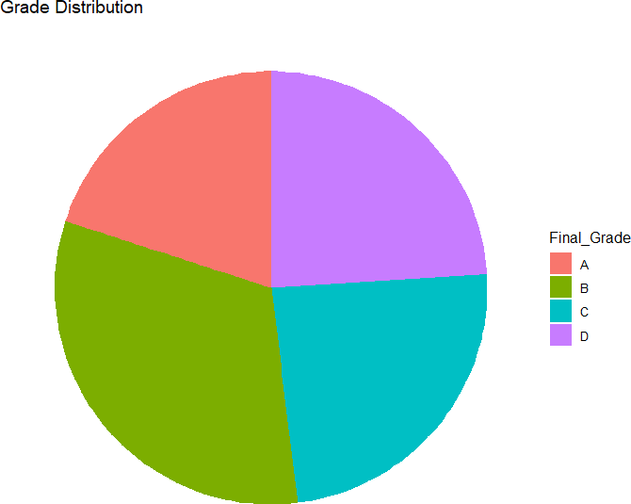

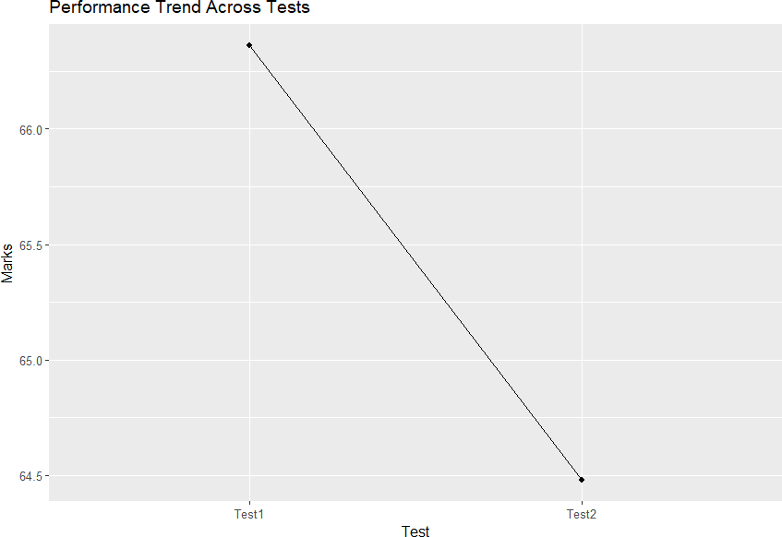

POST-LAB QUESTIONS (PROVIDE BRIEF ANSWERS TO THE FOLLOWING QUESTIONS)
- Which subject shows consistently low performance and why?

Ans: Subjects like DAA show comparatively lower performance due to higher conceptual difficulty.

- Why is a line chart suitable for trend analysis?

Ans: A line chart clearly shows changes in performance over time or across tests.

- What limitations does a pie chart have in analytics?

Ans: Pie charts are not suitable for precise comparison when many categories are present.

- How can this analysis help curriculum planning?

Ans: It helps identify difficult subjects and supports syllabus revision and improved teaching methods.

- How can such visualizations be integrated into AI-driven academic analytics

Ans: They can be used to train AI models for performance prediction and personalized learning recommendations.

ASSESSMENT

Description | Max Marks | Marks Awarded
Pre Lab Exercise | 5
In Lab Exercise | 10
Post Lab Exercise | 5
Viva | 10
Total | 30
Faculty Signature

